SPRING INTERNSHIP PROJECT REPORT
TEAM B

Agentic AI in Business Insights and Decision Support Assistant

Name: Somwrik Sinha
Course: B.Tech Biotechnology
Institute: Adamas University
Project Guide / Mentor Name: Mr. Santanu Karmakar

Team B Members:
Somwrik Sinha, Subhranil Das, Anushka Jha, Subham Bose


Period of Internship: 21st January 2026 – 31st March 2026

Report submitted to: IDEAS – Institute of Data Engineering, Analytics and Science Foundation, ISI Kolkata

Abstract
The goal of this project is to make an Agentic AI system that uses sales data to help businesses make decisions and get information. The system combines natural language processing with database querying so that users can easily interact with data. It makes SQL, gets data, and makes insights all by itself. Automation and AI models from n8n are used to put the workflow into action. A binary classifier makes sure that only useful queries are processed. The system creates SQL queries on the fly and gets back structured results. It also turns raw data into business insights that people can understand. The project shows how AI agents can help make decisions in real time. It makes data analysis easier by cutting down on the amount of work that needs to be done by hand. The system works like a smart business analyst.
- Introduction
In the current world, businesses operate with the help of data. But working with data involves SQL, programming, and other tools, which might not be easily accessible to non-programmers. This project is designed to address this issue by developing an Agentic AI-based Business Insights and Decision Support Assistance tool, where the user can easily pose questions and receive valuable insights using data.
Agentic AI is referred to as the ability of the machine to perform activities on its own, such as understanding the query posed by the user, generating queries to the database, and extracting the required data. An Agentic AI-based machine has been designed in this project, which can function as a business analyst.
The system utilizes several tools such as n8n for workflow automation, MySQL for data storage, and artificial intelligence models such as DeepSeek and Ollama for natural language processing. It has several parts such as a data storage pipeline, a relevance classifier for filtering queries, a SQL generator for converting queries into database queries, a validation part for safety, and an insight generator for presenting data in a simple manner for understanding.
The data set used for this project has information related to sales, such as data on products, categories, prices, units sold, and performance over the course of a month. Using this data, the system can identify the best-performing products, identify products that are performing poorly, calculate profit and revenue, and observe trends over time.
The first two weeks of the internship involved training on several key topics such as statistics for data science, data visualization, GitHub/cloud computing, Streamlit, machine learning (regression, classification), large language models, communication skills, deep learning, which helped in laying a strong foundation for the development of this project.
The main goal of this project is to show how AI can simplify data analysis and support better decision-making. By allowing users to interact with data in a simple and intuitive way, the system demonstrates the practical use of Agentic AI in real-world business scenarios.
2. Project Objective
The main objective of this project is to design and develop an AI-driven system that can assist in analyzing business data and generating meaningful insights in a simple and accessible way. The project aims to illustrate how Agentic AI can automate data analysis tasks and support decision-making in real-world business scenarios.
The specific objectives of the project are:
- To develop an intelligent system that can understand user queries in natural language and convert them into structured database queries for data retrieval.
- To demonstrate how AI can automate the process of generating business insights such as identifying best-performing products, analyzing profit and revenue, and understanding sales trends.
- To implement a relevance classification mechanism that ensures only meaningful and dataset-related queries are processed by the system.
- To present the retrieved data in a clear and human-readable format so that even non-technical users can easily understand and use the insights for decision-making.
- To explore the practical application of Agentic AI in business analytics while identifying existing limitations of the system, such as handling ambiguous queries, improving accuracy of SQL generation, and enhancing overall reliability with further development.
No hypothesis testing or survey-based analysis was conducted in this project, as the focus was on system development and workflow implementation using an existing dataset.

  - Methodology
This project was carried out in a structured manner, starting from data collection to building an automated AI-driven workflow for generating business insights. The entire system was designed using n8n, integrating SQL database operations with AI models to simulate an intelligent decision support system.
The workflow consists of multiple interconnected components (nodes), each performing a specific task.
The system is divided into two workflows:
- Workflow 1: Automated Data Ingestion and Storage Pipeline

Step 1: Data Collection
The dataset used in this project was a stationery sales dataset obtained in CSV format from Google Drive. It contained information related to products, including product ID, product name, category, cost per unit, selling price, units sold, and month. Refer to Figure 3 in Appendix.
The data was imported into the system using the “Google Drive Download” node in n8n, followed by extraction using the “Extract from File” node.

Step 2: Data Cleaning and Pre-processing
After extracting the raw dataset, a data preprocessing step was performed using a JavaScript Code node within the n8n workflow. This step was essential to transform the raw data into a structured and analysis-ready format.
Initially, the numerical fields such as selling price, units sold, and cost per unit were converted into numeric data types to ensure accurate calculations. In cases where values were missing or undefined, default values (0) were assigned to maintain consistency and avoid errors during computation.
Based on these cleaned values, important business metrics were calculated:
- Revenue was calculated as the product of selling price and units sold.
- Cost was calculated using cost per unit and units sold.
- Profit was derived by subtracting total cost from revenue.
- Margin was calculated as the percentage of profit over revenue and rounded to two decimal places for better readability.
In addition to numerical processing, text fields were also cleaned. The product ID and month values were converted into string format, trimmed to remove unnecessary spaces, and standardized (e.g., month converted to lowercase) to maintain uniformity across the dataset.
To ensure that each record could be uniquely identified and to prevent duplication during database insertion, a composite key was created by combining the product ID and month. This unique identifier played a crucial role in performing upsert operations in the database.
Overall, this preprocessing step ensured that the dataset was clean, consistent, and enriched with additional calculated fields, making it suitable for further analysis and integration into the AI-driven workflow.

Step 3: Database Storage
The cleaned and processed data was stored in a MySQL database table named sales_data. An upsert operation was used to insert new records and update existing ones based on the unique key. This ensured data consistency and prevented duplication.
- Workflow 2: AI-Driven Business Insights & Decision Support Engine.

Step 1: User Query Input
The system starts with a chat trigger node where the user enters a query in natural language.

Step 2: Relevance Classification
The query is first passed through a LLM based binary classifier model (Deepseek). This step ensures that only queries related to the dataset (such as sales, products, profit, etc.) are processed further. If the query is irrelevant, the system returns a predefined message.

Step 3: Conditional Routing
An IF node is used to route the workflow based on the classifier’s output:
- Relevant query → processed further
- Irrelevant query → rejected

Step 4: SQL Query Generation
A key component of the system is the automatic generation of SQL queries from user input. This was implemented using an AI model configured with a structured prompt that guides it to convert natural language queries into valid MySQL statements.
When a user enters a query, the system interprets the intent and generates a corresponding SQL query based on predefined logical rules. The process follows multiple steps to ensure accuracy and consistency.
First, the system determines how the data should be grouped. If the user query mentions categories, the data is grouped by category; otherwise, it is grouped by product name. This allows the system to perform meaningful comparisons across products or categories.
Next, the system identifies the appropriate metric to analyze. Depending on the keywords in the query:
- Profit-related queries use total profit
- Revenue or sales-related queries use total revenue
- Queries related to units sold use total units
If no specific metric is mentioned, the system defaults to revenue as the primary measure.
The system also checks whether the query includes any time-based condition. If a specific month is mentioned, a filtering condition is applied to retrieve data only for that month.
After identifying the grouping and metric, the system determines the sorting logic. Queries asking for the “best,” “top,” or “highest” results are sorted in descending order, while queries asking for the “worst,” “lowest,” or “least” results are sorted in ascending order.
To ensure meaningful results, the system removes invalid or irrelevant data by excluding records where the selected metric is zero. This helps avoid misleading outputs.
Finally, the system applies a limit to the number of results. If the user specifies a number (e.g., top 3), that number is used. If not, a default limit is applied, and in cases like “best” or “worst,” only one result is returned.
The generated SQL query follows a standard structure with SELECT, FROM, WHERE (if applicable), GROUP BY, ORDER BY, and LIMIT clauses. The system ensures that only valid and safe queries are produced, which are then passed to the database for execution.
This automated SQL generation process allows users to retrieve complex insights without needing any knowledge of database query languages, making the system more accessible and efficient.

Step 5: SQL Cleaning and Validation
The generated SQL query is passed through a validation layer implemented using a Code node. This step:
- Removes unwanted formatting
- Ensures only SELECT queries are executed
- Prevents unsafe operations (e.g., DELETE, DROP)
- Adds default limits if missing

Step 6: Database Query Execution
The validated SQL query is executed on the MySQL database using the “Execute SQL Query” node. The database returns the requested results.

Step 7: Data Formatting
The raw output from the database is processed using another Code node. The data is structured and converted into a readable format for further processing.

Step 8: Insight Generation
The formatted data is then passed to an AI model (here Deepseek), which converts it into a human-readable business insight. The response includes rankings, comparisons, and clear explanations.

Step 9: Final Output
The final answer is cleaned and presented to the user in a simple and understandable format.

3.1 Tools and Technologies Used
- n8n (workflow automation platform)
- MySQL (database management)
- AI models (DeepSeek, OpenAI, Ollama)
- JavaScript (for data processing and validation)
- Google Drive (data source)

3.2 Workflow Representation
The overall workflow of the system can be summarized as:
User Query → Relevance Classifier → IF Condition (Relevant/Not Relevant) → SQL Generation → SQL Validation → Database Execution → Data Formatting → Insight Generation → Final Output

Refer to Figure 1, illustrating the end-to-end n8n workflow architecture.

3.3 Analytical Approach
The project mainly focuses on descriptive data analysis rather than predictive modeling. The system performs:
- Product performance analysis
- Revenue and profit comparison
- Sales trend analysis over time
- Category-wise performance evaluation
No machine learning model training or hypothesis testing was conducted, as the objective was to build an automated decision support system using existing data.

3.4 Limitations of the Methodology
While the system performs well for structured queries, certain limitations were observed:
- Difficulty in handling highly ambiguous or complex queries
- Occasional inaccuracies in SQL generation
- Dependence on prompt quality for correct outputs
- Limited ability to perform advanced predictive analysis
These limitations indicate that further improvements and training are required to enhance system performance.

3.5 Code and Implementation
The logic for data preprocessing, SQL validation, and formatting was implemented using JavaScript within n8n Code nodes. Due to platform-based development, the workflow itself serves as the main implementation. The project workflow can be exported as a JSON file for reuse and further development.

  - Data Analysis and Results
The developed system was used to analyze a sales dataset and generate insights based on user queries. The analysis was performed dynamically, meaning that instead of fixed reports, the system generated results in real-time depending on the user’s input. Figure 2 demonstrates a sample query-response interaction.

4.1 Product Performance Analysis
The system was able to identify top-performing and low-performing products based on different metrics such as revenue, profit, and units sold. By grouping data at the product level and applying aggregation functions, it provided ranked outputs such as best product, worst product, and top-selling items.
This helped in understanding which products contribute the most to business performance and which ones require improvement.

4.2 Sales and Units Analysis
The system successfully analyzed sales volume by calculating total units sold for different products. Queries like “most sold product” or “least sold product” were handled effectively, allowing comparison of product popularity.
This type of analysis is useful for inventory planning and demand forecasting.

4.3 Revenue and Profit Analysis
One of the key strengths of the system is its ability to evaluate financial performance. It calculates and compares revenue and profit across products and categories.
The system can:
- 1) Identify high-revenue products
- 2)Detect low-profit or loss-making products
- 3)Compare overall financial contribution of different items
This provides valuable insights for pricing strategies and cost optimization.

4.4 Category-wise Analysis
The system also supports category-level analysis, allowing users to understand which categories perform better in terms of sales and profit. By grouping data by category, it helps in identifying strong and weak segments within the business.

4.5 Time-based Analysis
Using the month field, the system can analyze trends over time. It enables queries related to monthly sales and performance, helping users understand seasonal variations and trends.

4.6 Overall System Performance
The system demonstrated the ability to:
- Convert natural language queries into SQL queries
- Retrieve relevant data from the database
- Present results in a simplified and human-readable format
It effectively reduces manual effort and makes data analysis more accessible to non-technical users.

4.7 Limitations Observed
Despite achieving the intended functionality, several limitations were observed during testing:
- The same query sometimes returns different results due to variations in AI model responses.
- Different queries with similar intent may occasionally produce the same single result, reducing diversity in outputs.
- The accuracy of results depends heavily on prompt design and requires further refinement.
- AI models may interpret the same query differently, leading to inconsistent outputs.
- The final responses, although designed to be polished and user-friendly, do not always meet expectations in terms of clarity or correctness.
These limitations indicate that the system still requires further tuning and optimization, especially in prompt engineering and model consistency.
4.8 Future Enhancements in Output Representation
While the current system successfully generates responses based on user queries, the output format is not always optimal for end-user interaction. As observed in Figure 2, the system currently returns responses in a semi-structured format containing JSON-like text with escape characters (e.g., “\n”), which reduces readability and user experience.
To enhance usability, future improvements will focus on transforming system outputs into a more natural, conversational, and user-friendly format, similar to modern AI assistants.
Current Output Format (System Generated):
Contains raw structured text
Includes escape characters (e.g., “\n”)
Lacks proper formatting and clarity
Not optimized for non-technical users
Proposed Improved Output Format:
The system will be enhanced to generate responses in a clean, structured, and human-readable format. Instead of returning raw data, the AI will present insights in a conversational manner.
Example:
User Query:
“Which is the best product based on profit in January?”
Improved Output:
The top-performing product in January based on profit is Notebook A4, generating a total profit of ₹9000.
Other high-performing products include:
Notebook A5 – ₹7000
Ball Pen Blue – ₹3840
Ball Pen Black – ₹3600
Pencil HB – ₹3600
This format improves clarity, enhances readability, and provides a more intuitive understanding of the results.
Planned Improvements:
- Removal of raw JSON formatting from final output
- Automatic structuring of results into bullet points or ranked lists
- Use of natural language generation (NLG) for explanation
- Improved formatting using line breaks and spacing
- Context-aware responses for better interaction
These enhancements will make the system more aligned with real-world AI assistants and significantly improve the overall user experience.

4.9 Summary of Findings
Overall, the system successfully demonstrates how an AI-driven approach can be used for business data analysis. It provides quick insights, automates complex processes, and simplifies interaction with data.
However, it also highlights the challenges of working with AI models, particularly in terms of consistency and reliability. With further improvements, the system has strong potential to become a robust decision support tool.
  - Conclusion
The project successfully demonstrates the development of an Agentic AI-based system for generating business insights from sales data. The system was able to process natural language queries, convert them into SQL queries, retrieve relevant data, and present the results in a simplified and user-friendly format. This confirms that AI can be effectively used to automate data analysis and support decision-making without requiring technical expertise.
From the analysis performed, it was observed that the system can identify key business insights such as best-performing products, low-performing items, sales trends, and category-wise performance. It was also able to handle common queries related to revenue, profit, and units sold, showing its usefulness as a decision support tool. The workflow-based design ensured that each step, from query processing to final output, was automated and logically structured.
However, the findings also highlight certain limitations. It was observed that the same query may sometimes produce different results, and different queries may occasionally return similar outputs. The performance of the system depends significantly on prompt design and the behavior of AI models, which can vary. In some cases, the generated responses were not as clear or accurate as expected. These observations indicate that while the system is functional, it still requires further refinement to improve consistency and reliability.
Based on these findings, it is recommended that future work should focus on improving prompt engineering, enhancing SQL generation accuracy, and introducing mechanisms to ensure more consistent outputs. The system can also be extended by incorporating advanced features such as predictive analytics, real-time data integration, and better user interaction interfaces.
In conclusion, the project provides a strong foundation for developing intelligent, AI-driven business analytics systems. With further improvements, it has the potential to become a reliable and scalable solution for real-world decision support applications.
- Appendix
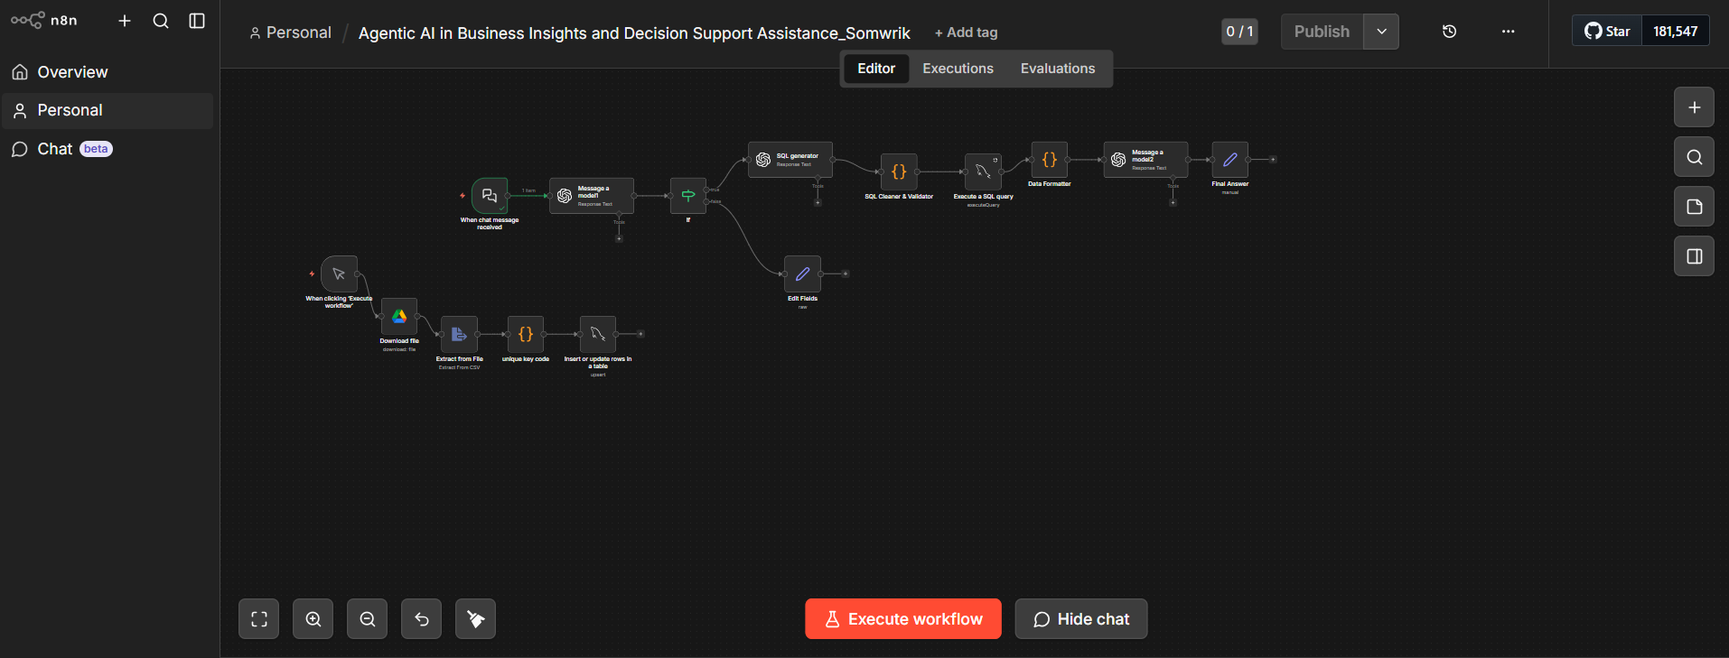
Figure 1: n8n Workflow Diagram

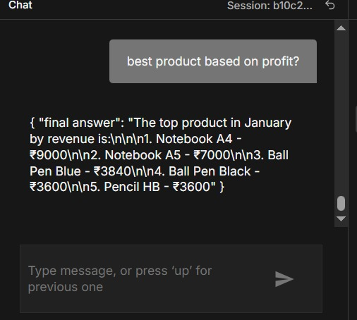
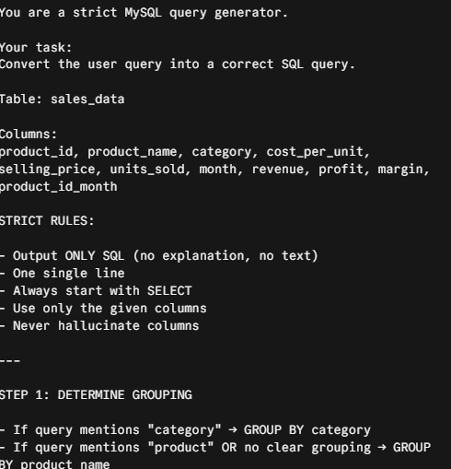

Figure 3: SQL Generator Code Snippet
Figure 2: Sample Query and Output
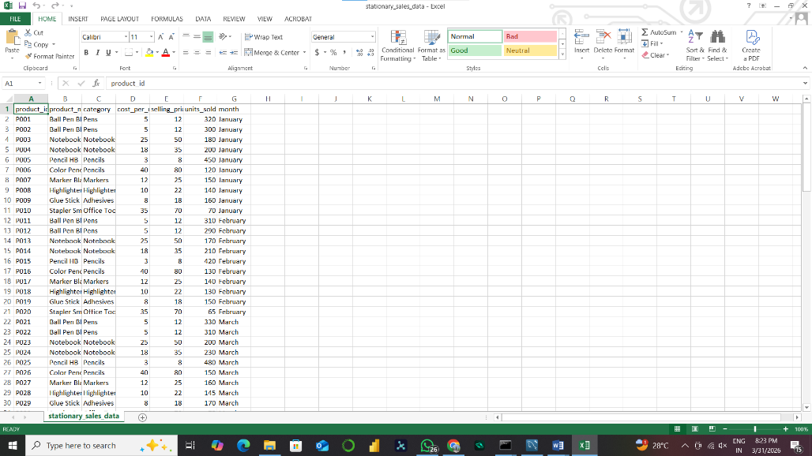

Figure 4: Sample sales_data csv
- References
- Agentic AI Project Workbook by Santanu Karmakar
- ISI Lecture notes and video sessions
- We have also referred to the Github of Mr. Santanu Karmakar for knowledge.
- Github repository link - https://github.com/SomwrikSinha/agentic-ai-business-insights

